NAME: M. Arham Hussain Khan
TASK 1:

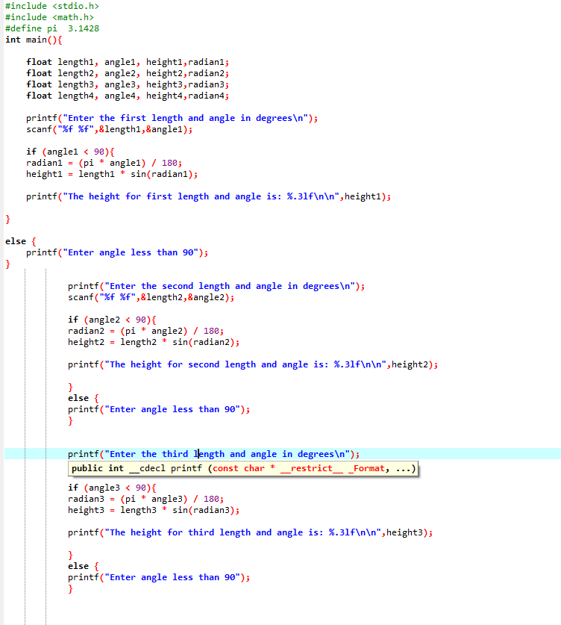
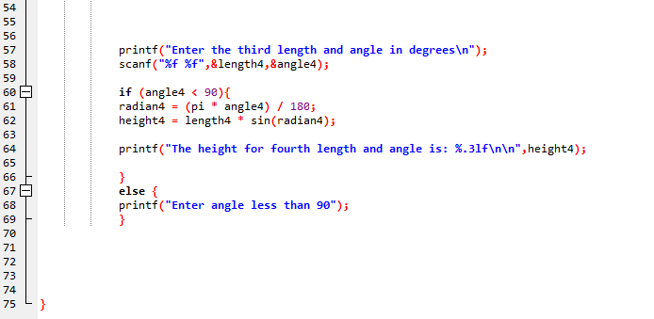

TASK 1 Console:
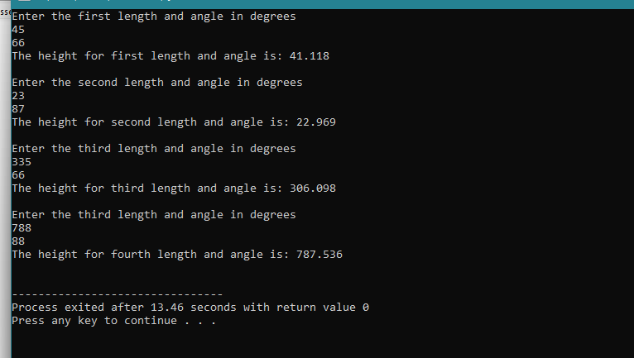

TASK 2:
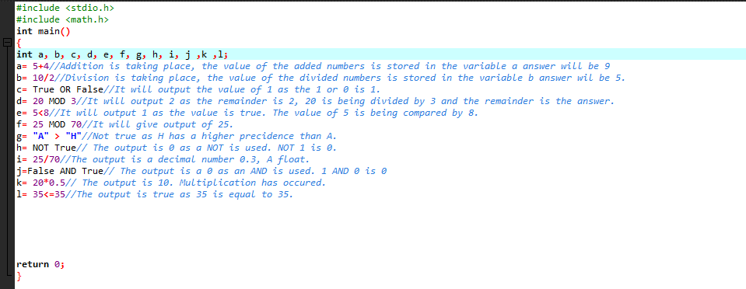

TASK 3:
Answer: The code prints 0. This is due to the fact that the format specifier is defined as %d (Correction: %f). Moreover, the operation f +g is already assigned a value 0.3 which is why the answer is getting 0, only f+g should be written in the printf() statement . It should then give the right answer 0.3.
TASK 4:
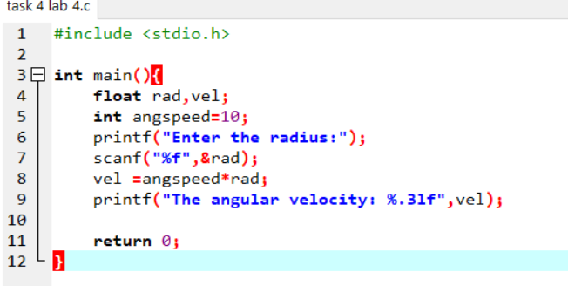

Task 4 PART A:
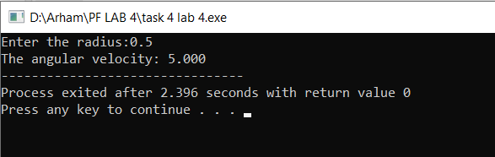
Task 4 PART B:
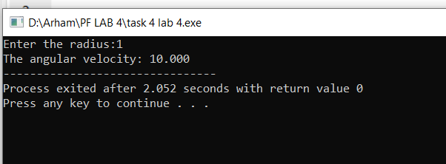
Task 4 PART C:
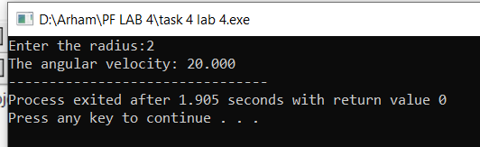
TASK 5:
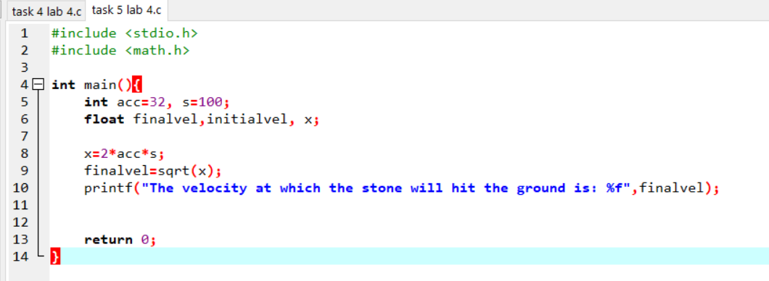
OUTPUT:
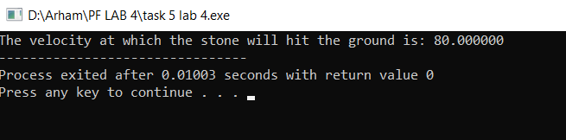
TASK 6:
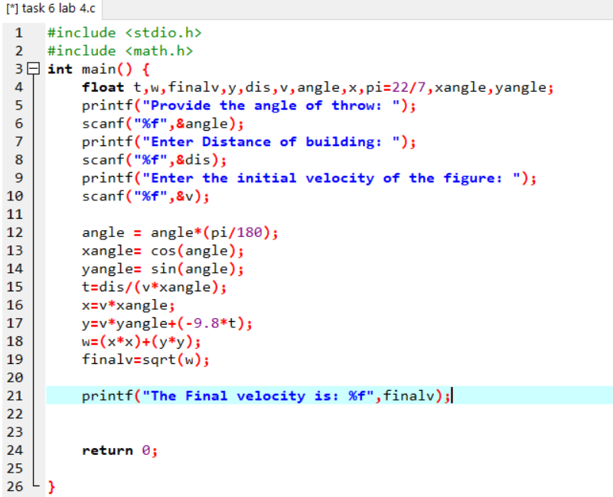
Output:
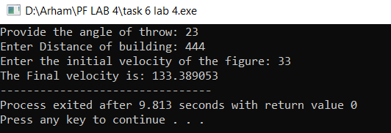

TASK 7:
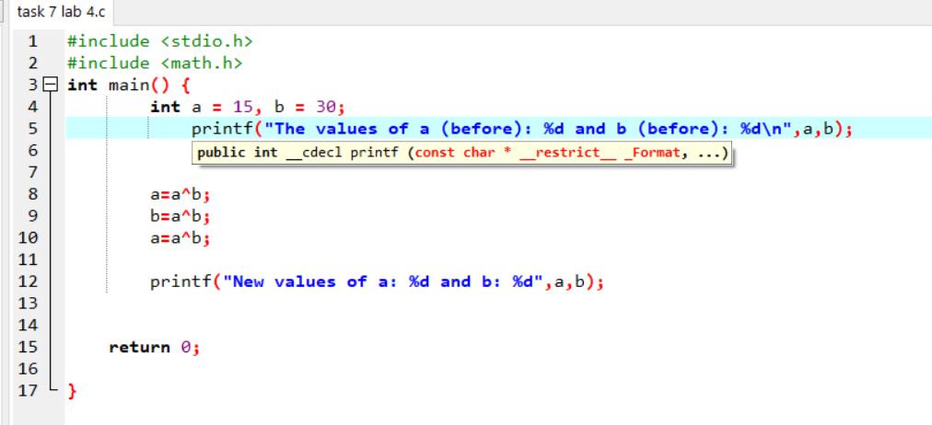
OUTPUT:
